Tests For The Hangman Game

Name: Fredrik Strömbäck

LNU-email: fs222uv@student.lnu.se

GitHub repo: https://github.com/Strombach/fs222uv_1dv600

Release: https://github.com/Strombach/fs222uv_1dv600/releases/tag/3.0

1. Test Plan

What are the objectives of the testing in this iteration?
My objective is to write manual and automated tests for the code I implemented in iteration 2.
This is for me to learn how to write both test cases, plan and implement manual and automated tests.

What to test and how?
For the manual tests I'm going to test UC3 where the gamer should be able to quit the game from anywhere in the game, after confirming to do so. The other part to test is where the gamer can enter his/her name in UC2 “Play Game”, this is the first five steps in the main scenario of UC2. I will also test if the gamer enters a name that is to short or to long, because the game only accepts a name that is three character long.
These tests will be running dynamically so starting the application is necessary.

The automated unit tests will be testing the constructor for the Gamer class to see that the class is initiated correctly and throws exceptions when the input is wrong. The createLetter method in the Word class will be tested to see that the app can create individual letter objects. Both the Gamer constructor and Word-class methods will have at least two tests each.
I will be using the framework Mocha with Chai assertion library for all the automated unit tests.
To start automated test, enter “npm run test” in the console.

Time Plan
Task | Estimated Time | Actual Time
Writing manual test cases. | 2h | 2h 45m
Running manual tests. | 15m | 5m
Automated tests | 4h | 5h 15m
Test report | 2h | 30m

Use Cases To Be Tested

Use Case 2 Play Game
Preconditions: The game is running and the main menu is displayed.

Main success scenario (Basic Flow)
- The gamer chooses the option “Play game” in the menu.*
- The system ask for a name that the user wants to have in the game.*
- The gamer enters a name.*
- The system picks a word from a word list.*
- The system displays info about the gamer and the word with the letters hidden.*
- The gamer guesses a letter.
- The system replaces one or more of the underlines, where the guessed letter matches the hidden letter, with the correctly guessed letters.
- The gamer guesses all the letters correctly.
- The system displays that the gamer have won and returns to the menu.

Alternative Flow
3a. The gamer enters a name that is too short or too long. *
- The system displays an error message and rejects the entry.
- Go to 2.

* = Part to be tested

Use Case 3 Quit Game
Precondition: The game is running.
Post condition: The game is terminated.

Main scenario
- Starts when the user wants to quit the game.
- The system prompts for confirmation.
- The user confirms.
- The system terminates.

Alternative scenarios
3.1. The user does not confirm
- The system returns to its previous state

Test Cases

TC1.1 Name of the gamer is stored successfully.
This is tested to see that game can take and store a name into the gamer class.

Use Case: First five steps of UC2 “Play Game”
Scenario: The name is stored successfully.
Precondition: The app is running and user can see the menu.

Test steps
- Press number 1 and press enter.
- System shows “Enter a three character name or a "Q" to quit the game”
- Enter “asd” and press enter
Expected
- The system should show the text “Your name is: “asd” on the second row.
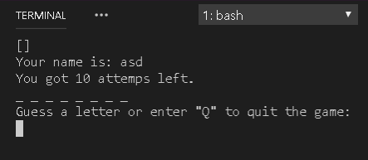
- Also “[]” on the first row, “You got 10 attempts left.” on the third row, a random number of underlines on the fourth row and “Guess a letter or enter "Q" to quit the game:” on the last row.

Comments
Passed

TC 1.2 Name entered is to short.
This test is to test that the gamer can’t enter a name that is less than 3 characters long.

Use Case: First five steps of UC2 “Play Game”
Scenario: The name is to short to be stored and the system ask the gamer for a new name.
Precondition: The app is running and user can see the menu.

Test steps
- Press number 1 and press enter.
- System shows “Enter a three character name or a "Q" to quit the game”
- Enter “qw” and press enter

Expected
- Should add the text “Too few characters!”in the console.

Comments
Passed

TC 1.3 Name entered is to long.
This test is to test that the gamer can’t enter a name that is more than 3 characters long.

Use Case: First five steps of UC2 “Play Game”
Scenario: The name is to long to be stored.
Precondition: The app is running and user can see the menu.

Test steps
- Press number 1 and press enter.
- System shows “Enter a three character name or a "Q" to quit the game”
- Enter “zxcv” and press enter

Expected
- Should add the text “Too many characters!”in the console.

Comments
Passed

TC 2.1 Quit the game from menu.
Testing that the gamer can quit the game from the menu

Use Case: Use Case 3 Quit Game
Scenario: The gamer quits the game from the menu.
Precondition: The app is running and user can see the menu.

Test steps
- Enter number 2 and press enter.
- System ask for confirmation with the text “Are you sure you want to quit? (y/n):”
- Enter lowercase “y” and press enter.

Expected
- The whole game should be terminated.

Comments
Passed

TC 2.2 Quit the game instead of entering name.
Testing that the gamer can quit the game from “enter name” state.

Use Case: Use Case 3 Quit Game
Scenario: The gamer quits the game instead of entering the name.
Precondition: The app is running and user can see the menu.

Test steps
- Enter number 1 and press enter
- System shows “Enter a three character name or a "Q" to quit the game”
- Enter uppercase “Q” and press enter.
- System ask for confirmation with the text “Are you sure you want to quit? (y/n):”
- Enter lowercase “y” and press enter

Expected
- The whole game should be terminated.

Comments
Passed

TC 2.3 Quit the game from in the actual game
Testing that the gamer can quit the game from the main part of the game where the gamer can guess the letters of the word chosen.

Use Case: Use Case 3 Quit Game
Scenario: The gamer quits the game instead of guessing a letter.
Precondition: The app is running and user can see the menu.

Test steps
- Enter number 1 and press enter
- System shows “Enter a three character name or a "Q" to quit the game”
- Enter “asd” and press enter
- System ask gamer to guess a letter with the text ”Guess a letter or enter "Q" to quit the game:”
- Enter uppercase “Q” and press enter.
- System ask for confirmation with the text “Are you sure you want to quit? (y/n):”
- Enter lowercase “y” and press enter

Expected
- The whole game should be terminated.

Comments
Passed

Manual Test Report

Test | UC2 | UC3
TC1.1 | 1/OK | 0
TC1.2 | 1/OK | 0
TC1.3 | 1/OK | 0
TC2.1 | 0 | 1/OK
TC2.2 | 0 | 1/OK
TC2.3 | 1/OK | 1/OK
COVERAGE & SUCCESS | 4/OK | 3/OK

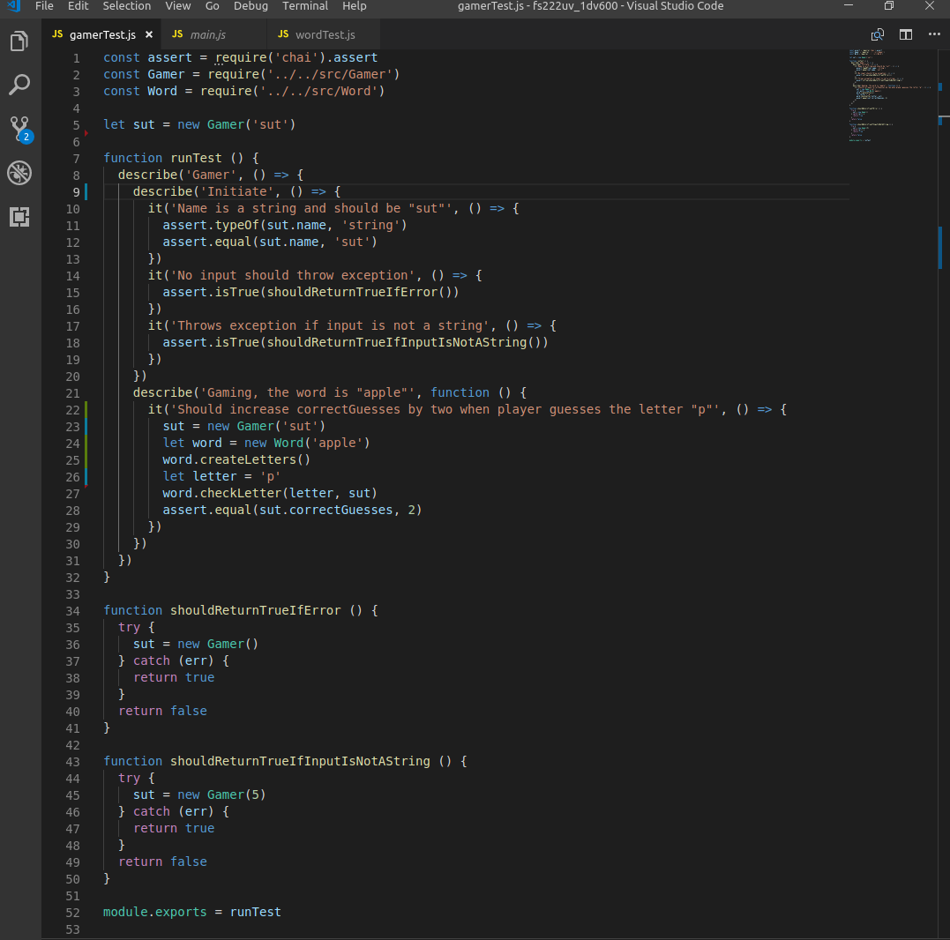
Automated Tests
Gamer
The first test is of the gamer class initiation. Here I test that it can take an input and put it into the name variable and that it should be a string. Also test that if the class is initiated without an input or that the input is something else than a string, it should throw an exception.
The second part I test that if the gamer guesses a letter correctly (or in this case, two letters), the correctGuesses counter should increase with the number of correct letters.

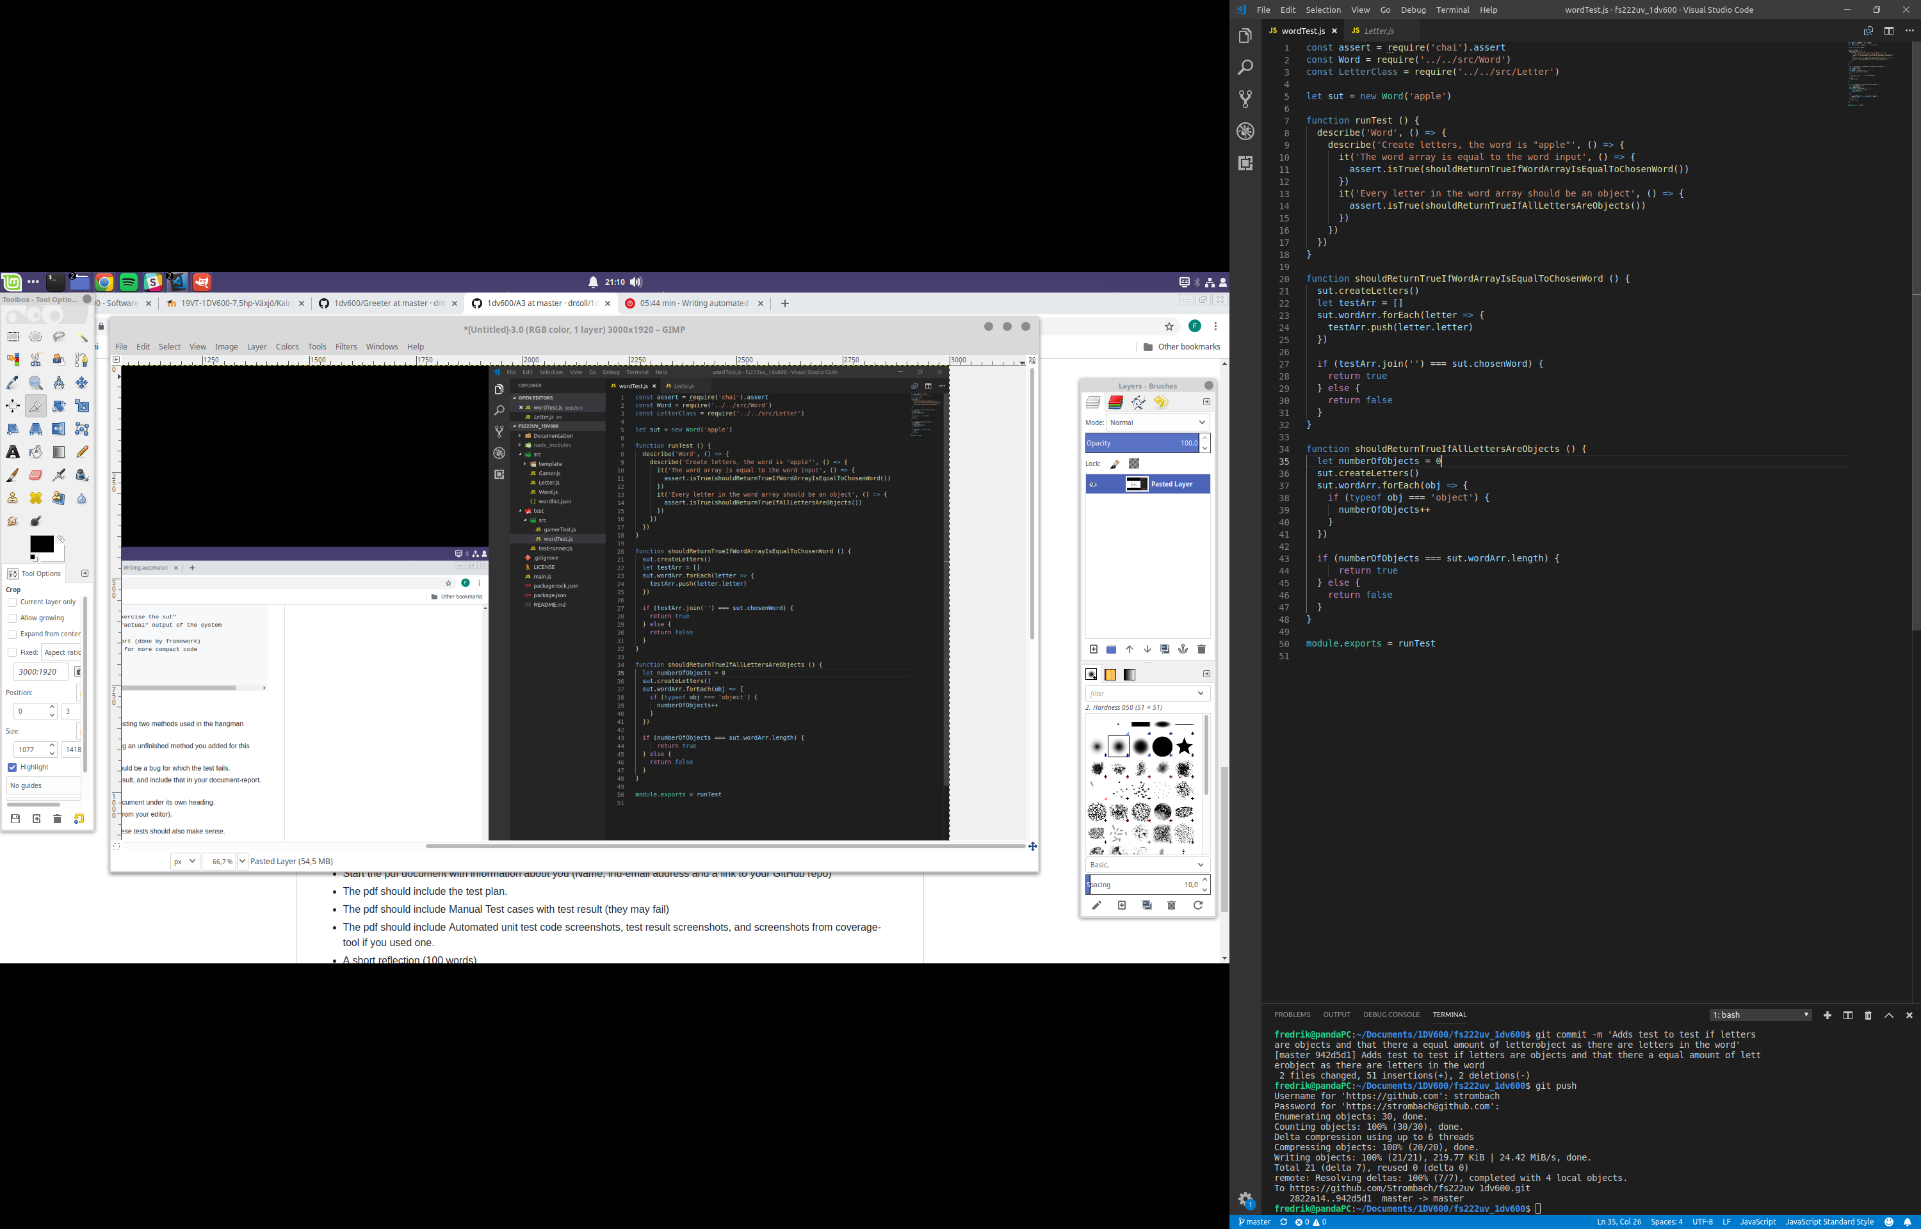
Word
This is all the tests for the word class method createLetters. Here I test if all the letters in the word array are independent objects and that there are actually one letter object for each letter in the chosen word (in this case the word is “apple”).

High-scores
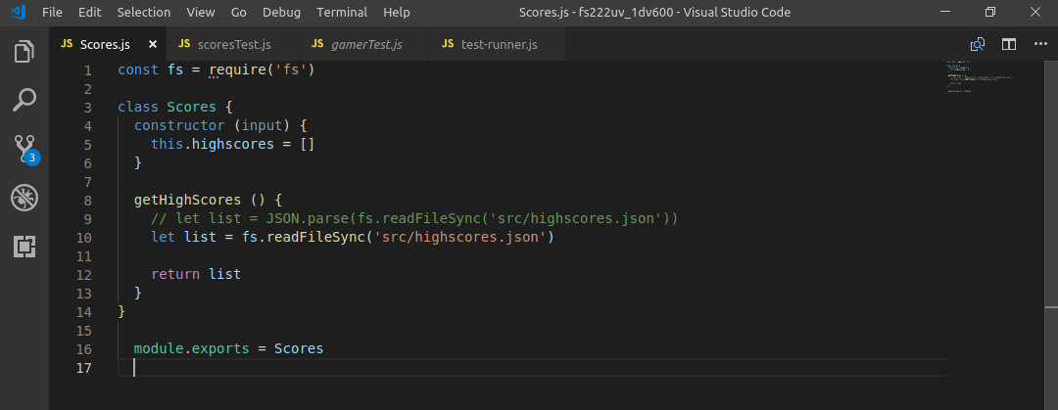
Here is a test to try if the method can fetch a Json-file where I will store all the highs-cores. The function should return an array from the file. This test should fail because I don’t parse the file so the result is not an readable Javascript array. The code to fix this is commented in the the code.

The code for the Score class.

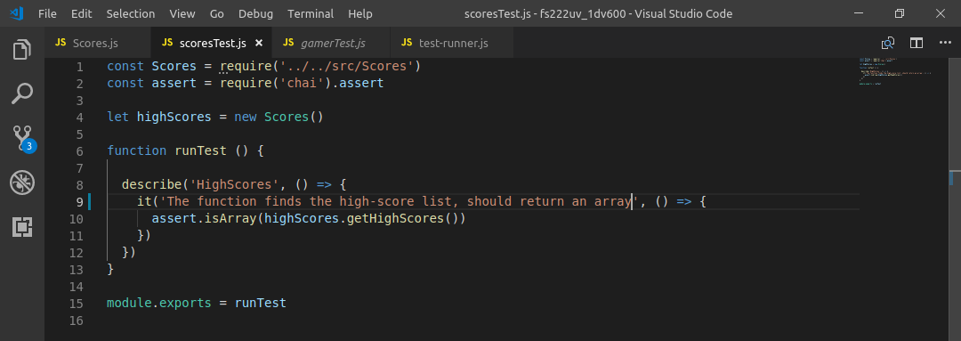
Tests for the getHighScores-method:

Results
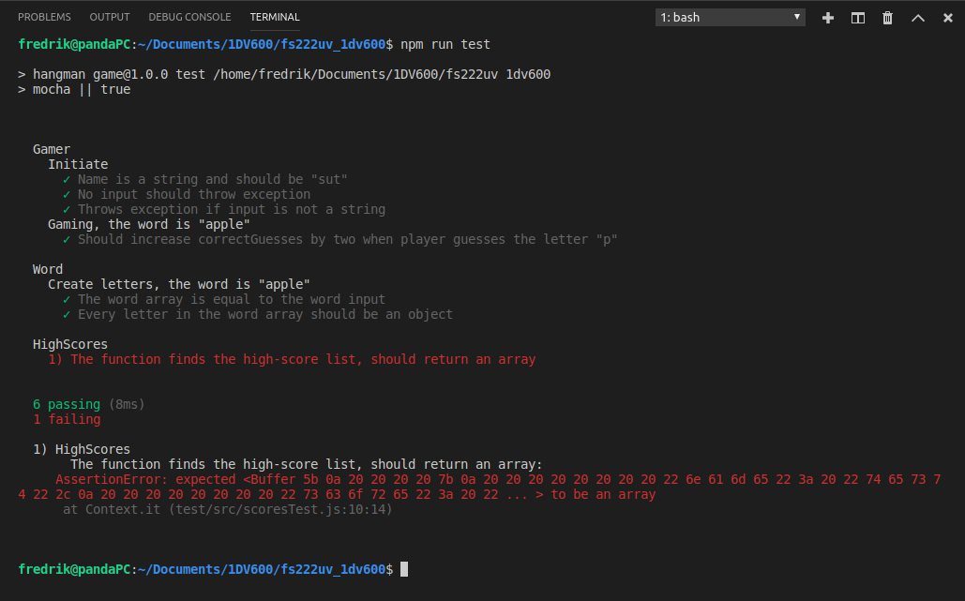
This is all the results for all automated tests:

Reflection
This was the most fun part of all the themes so far, learning how to use a testing framework and writing my own tests was fun and gave me a good learning experience. The easiest part was to write all the manual test, because this is the way I've been testing my apps to this point. The hardest parts was to come up with all different tests when the application is so small, and I noticed that I hadn’t really written my code so that it would be easy to do meaningful automated tests.

